**Raptor Analytics development environment**

1. Install regular Raptor ( any version ) on the PC and apply valid license
2. From the repository get the latest version of the Raptor SDK build

Current location is in here:

[https://subversion.assembla.com/svn/peddinghaus^Raptor.Raptor/branches/Igor/ClampsEventLogger](https://subversion.assembla.com/svn/peddinghaus%5eRaptor.Raptor/branches/Igor/ClampsEventLogger)

1. Build the Raptor SDK version.
2. From the repository get the latest version of the RaptorAnalytics

Current location is in here:

[https://subversion.assembla.com/svn/peddinghaus^Raptor.Raptor/branches/Igor/RaptorAnalytics/RaptorAnalytics](https://subversion.assembla.com/svn/peddinghaus%5eRaptor.Raptor/branches/Igor/RaptorAnalytics/RaptorAnalytics)

1. Open the RaptorAnalytics solution and make sure that the following references

Point to the proper location where Raptor SDK DLLs are residing.

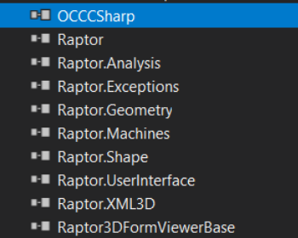

Normally Dlls would be in the **..trunk\bin\Debug** directory

1. For running application you would need to copy the DLLs from the Raptor SDK solution to the bin\debug directory of the RaptorAnalytics solution if not copied

automatically by Visual Studio.

**Running application**

1. Start Analytics application
2. From the machines bull down menu select “XDM630”

This is the only processor that had been instrumented till now.

1. You can load into Analytics part, multipart or CNC code,

You can also load and save settings if you have them.

1. Load any available file by using menu or icons
2. Click on the “CNC”  icon to process material
3. Click on the “Raptor Analytics”  icon to perform analysis

of the part.

1. If program worked, you will see detailed data for the machine

And clamp visualization:

